**Class Description**

CD-01: User

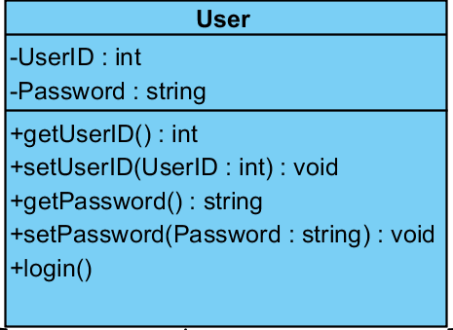

Entities

|  |  |  |  |
| --- | --- | --- | --- |
| ID | Name | Description | Type |
| 1. | UserID | User in System Id number. | int |
| 2. | Password | Password User in System | string |

Method Detail

Method Name : getUserID():int  
Description : Get value of UserID  
Return : UserID Value  
  
Method Name : setUserID(UserID:int):void  
Description : Set a value of UserID   
Return : UserID Value

Method Name : getUPassword():string  
Description : get value of password  
Return : Password Value

Method Name : setUPassword():void  
Description : set value of password  
Return : Password Value

Method Name : Login   
Description : Method for Login into the system.  
Return : Status of login.

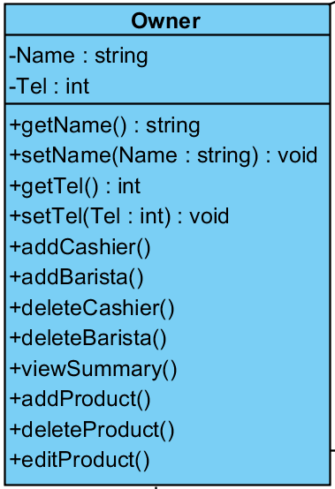CD-02: Owner

Entities

|  |  |  |  |
| --- | --- | --- | --- |
| ID | Name | Description | Type |
| 1. | Name | Name of user in system. | string |
| 2. | Tel | Telephone number of user in system. | int |

Method Detail

Method Name : getName():string  
Description : Get value of name.  
Return : name  
  
Method Name : setName():void  
Description : set value of name.  
Return : name

Method Name : getTel():int  
Description : Get value telephone number of user.  
Return : telephone number

Method Name : setTel():void  
Description : Set value telephone number of user.  
Return : telephone number

Method Name : addCashier  
Description : Create Cashier information in system  
Return : Cashier information

Method Name : addBarista  
Description : Create Barista information in system  
Return : Barista information

Method Name : deleteCashier  
Description : Delete Cashier information from system  
Return : Delete Cashier information

Method Name : deleteBarista  
Description : Delete Barista information from system  
Return : Delete Barista information

Method Name : viewSummary  
Description : View Summary of order from TransactionSummary Class  
Return : Data of Summary

Method Name : addProduct  
Description : CreateProduct information in system  
Return : Product information

Method Name : deleteCashier  
Description : Delete Cashier information from system  
Return : Delete Cashier information

Method Name : editCashier  
Description : EditCashier information from system  
Return : Edit Cashier information

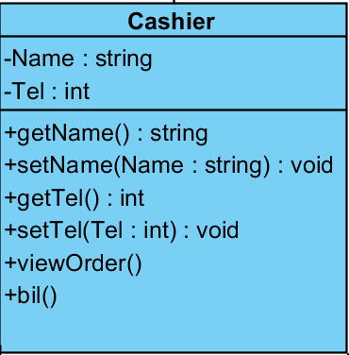CD-03: Cashier

Entities

|  |  |  |  |
| --- | --- | --- | --- |
| ID | Name | Description | Type |
| 1. | Name | Name of user in system. | string |
| 2. | Tel | Telephone number of user in system. | int |

Method Detail

Method Name : getName():string  
Description : Get value of name.  
Return : name  
  
Method Name : setName():void  
Description : set value of name.  
Return : name

Method Name : getTel():int  
Description : Get value telephone number of user.  
Return : telephone number

Method Name : setTel():void  
Description : Set value telephone number of user.  
Return : telephone number

Method Name : viewOrder  
Description : View order by ArrayList from Order Class  
Return : Order List

Method Name : bill  
Description : Use data about bill from Paymeny Class  
Return : Bill information

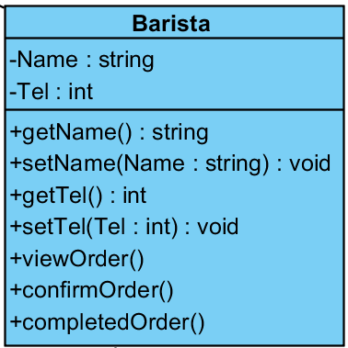CD-04 : Barista

Entities

|  |  |  |  |
| --- | --- | --- | --- |
| ID | Name | Description | Type |
| 1. | Name | Name of user in system. | string |
| 2. | Tel | Telephone number of user in system. | int |

Method Detail

Method Name : getName():string  
Description : Get value of name.  
Return : name  
  
Method Name : setName():void  
Description : set value of name.  
Return : name

Method Name : getTel():int  
Description : Get value telephone number of user.  
Return : telephone number

Method Name : setTel():void  
Description : Set value telephone number of user.  
Return : telephone number

Method Name : ConfirmOrder  
Description : Confirm order in order class  
Return : Command of order.

Method Name : ConpleatedOrder  
Description : Mark order was completed In order class.  
Return : Completed or Incompleted of order.

CD-05:Order

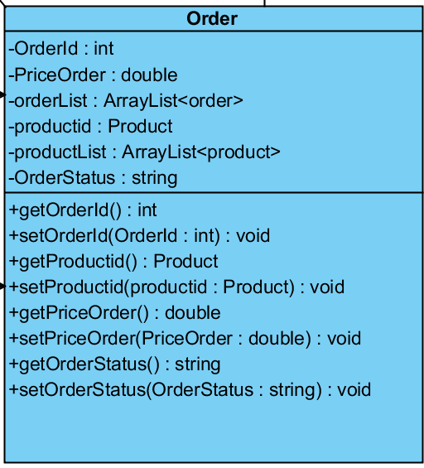

Entities

|  |  |  |  |
| --- | --- | --- | --- |
| ID | Name | Description | Type |
| 1. | OrderID | Number of order for identity order. | int |
| 2. | PriceOrder | Price of order | double |
| 3. | OrderList | Contain all of order | array |
| 4. | productId | Id of product for identity new product object from ProductClass | Product |
| 5. | productList | Contain all list of product for order | Array product |
| 6. | OrderStatus | Status about order suchas, Requesting,  Doing and Completed | string |

Method Detail

Method Name : getOrderID():int  
Description : Get value of OrderID.  
Return : OrderId

Method Name : setOrderID():void  
Description : Set value of OrderID.  
Return : OrderId

Method Name : getProductID (): product  
Description : Get value of productID and use object from ProductClass  
Return : ProductID

Method Name : setProductID ():void   
Description : Set value of productID and use object from ProductClass.  
Return : ProductID.

Method Name : getPriceOrder():double  
Description : get value of pricreorder.   
Return : PriceOrder

Method Name : setPriceOrder():void   
Description : set value of pricreorder.   
Return : PriceOrder

Method Name : getOrderStatus():string  
Description : get value of OrderStatus.   
Return : OrderStatus

Method Name : setOrderStatus():void  
Description : set value of OrderStatus.   
Return : OrderStatus

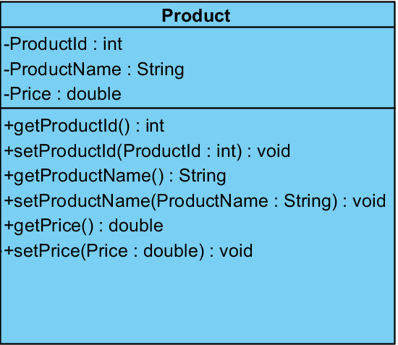CD-06:Product

Entities

|  |  |  |  |
| --- | --- | --- | --- |
| ID | Name | Description | Type |
| 1. | ProductID | Number of product for identity product. | int |
| 2. | ProductName | Name of product | String |
| 3. | Price | Price of product | double |

Method Detail

Method Name : getProductID():int  
Description : Get value of ProductID  
Return : ProductId  
  
Method Name : setProductID():void  
Description : set value of ProductID  
Return : ProductId

Method Name : getProductName():string  
Description : Get value of ProductName  
Return : ProductName  
  
Method Name : setProductName():void  
Description : set value of ProductName  
Return : ProductName

Method Name : getPrice():double  
Description : get value of price.   
Return : Price

Method Name : setPrice():void  
Description : set value of price.   
Return : Price

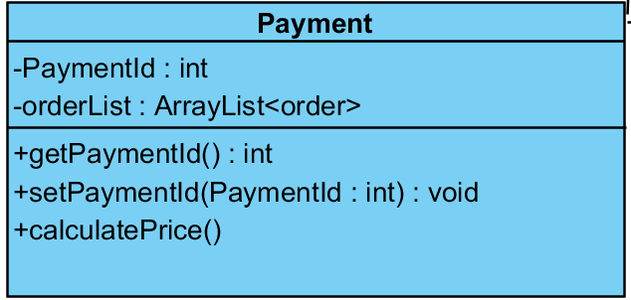CD-07 : Payment

Entities

|  |  |  |  |
| --- | --- | --- | --- |
| ID | Name | Description | Type |
| 1. | PaymentID | Number of payment for identity payment | Int |
| 2. | OrderList | Contain all of order | array |

Method Detail

Method Name : getPaymentID():int  
Description : Get value of PaymentId.  
Return : PaymentID  
  
Method Name : setPaymentID():void  
Description : Set value of PaymentId.  
Return : PaymentID

Method Name : calculatePrice()  
Description : calculate price from order list  
Return : price of order

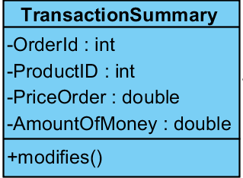CD-07 : TransactionSummary

Entities

|  |  |  |  |
| --- | --- | --- | --- |
| ID | Name | Description | Type |
| 1. | OrderID | Number of order for identity order. | int |
| 2. | ProductID | Number of product for identity product. | int |
| 3. | PriceOrder | Price of order | double |
| 4. | AmountOfMoney | Total of all of money from order | double |

Method Detail

Method Name : modifies()  
Description : Process task send to Database.  
Return : viewSummary